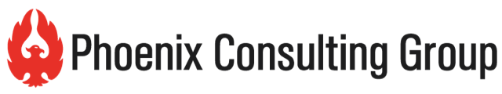

Partner Recruitment Checklist

 | Considerations
1. | Do you understand how your target customers prefer to buy?
2. | What is the purchase process and buyer’s journey?
3. | Who are the key partners or influencers in your market for your target audience?
4. | What is your competition doing for a distribution strategy? Is it successful or not? Is distribution where you can create a differentiating strategy?
5. | What are the criteria for you to build a successful channel? Strategy drives selection criteria. How will you know which distribution partners are right for your company and product?
6. | Have you identified a target channel and influence partner list?
7. | What is your value proposition to these companies? Why should they work with you? What’s in it for them?
8. | How is the customer experience improved through the channel? How is customer value created through partners?
9. | What are the terms, policies and pricing structures you are willing to offer?
10. | Have you identified strategic, operational, relationship fit and potential value for each company you are targeting?

Phoenix CG and Highland Team can help you with Partner Selection and Qualification.
Contact us for a complementary assessment call.
Deborah Henken, President, Highland Team, dhenken@highlandteam.com, 650-224-6295 www.highlandteam.com
Norma Watenpaugh, President Phoenix Consulting Group, normaw@phoenixcg.com, 888.848.9514, www.phoenixcg.com

